**OOP Topics**

1. **Class**
2. **Object**
3. **Variable**
4. **Method**
5. **Access Modifiers**
6. **Encapsulation**
7. **Abstraction**
8. **Inheritance**
9. **Polymorphism**
10. **Abstract Class/Method**
11. **Virtual Method**
12. **Sealed Class/Method**
13. **Static Class/Method**
14. **Interface**

* **Inheritance**

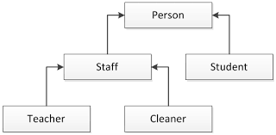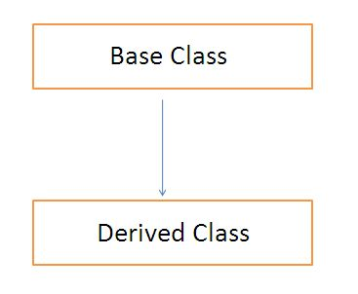

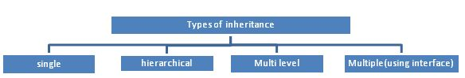

* **Virtual methods**
* **Access Modifiers In C# (+encapsulation)**

|  |  |
| --- | --- |
| Modifier | Description |
| public | There are no restrictions on accessing public members. |
| private | Access is limited to within the class definition. This is the default access modifier type if none is formally specified |
| protected | Access is limited to within the class definition and any class that inherits from the class |
| internal | Access is limited exclusively to classes defined within the current project assembly |
| protected internal | Access is limited to the current assembly and types derived from the containing class. All members in current project and all members in derived class can access the variables. |
| private protected | Access is limited to the containing class or types derived from the containing class within the current assembly. |

* **Contructor Methods type in inheritance**
* **Sealed member in class and inheritance**
* **New and override keywords for methods**

# Types of Classes in C#

# Aces Modifiers

* + Public
  + Private
  + Protected
  + Internal
  + Protected internal

Types:

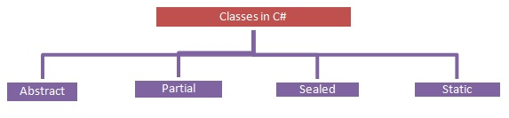

# Interface in C# (is a data contract, a data type)

# Multiple inheritance

# Inheritance between interface

# Polymorphism